

Data Technician

Name:
Course Date:
Table of contents
Day 1: Task 1 3
Day 1: Task 2 3
Day 1: Task 3 4
Day 2: Task 1 5
Day 3: Task 1 9
Day 3: Task 2 10
Day 3: Task 3 11
Day 4: Task 1 12
Day 4: Task 2 13
1. Scenario Background 13
2. Data Laws and Regulations 14
3. Azure Service Recommendations 14
4. Data Types and Data Modelling 14
5. Data Storage Formats and Structures in Azure 14
6. Additional Considerations 15
Submission Guidelines: 15
Course Notes 17
Additional Information 17

Day 1: Task 1

Please research and complete the below questions relating to key concepts of cloud.

Be prepared to discuss the below in the group following this task.

What can cloud computing do for us in the real-world? | Cloud computing powers everyday activities like streaming video and storing files online, while also enabling businesses to host websites, develop apps, and use powerful data analytics tools.
How can it benefit a business? | It provides businesses with benefits like scalability, cost savings, enhanced collaboration, and robust disaster recovery, allowing them to be more agile and flexible.  Hosting: Without having to worry about maintaining their own physical servers, businesses can host websites, blogs, and applications that interact with customers.  Cloud platforms allow developers to easily develop, test, and deploy apps without having to make significant upfront infrastructure investments.  AI and data analytics: Businesses utilise cloud services like machine learning and artificial intelligence to process massive volumes of data, identify trends, and provide forecasts.  Collaboration: Teams can collaborate in real time on projects using cloud-based tools, regardless of where they are physically located.  Scalability: Companies just must pay for the computer resources they use, and they can readily scale up or down as needed.  Data backup and recovery: To prevent data loss, the cloud offers a dependable and safe method for doing disaster recovery and data backup.
What’s the alternative to cloud computing? | Alternatives to cloud computing include edge computing, which processes data closer to the source, and on-premise infrastructure, which involves maintaining your own servers on your own property. Other options are private clouds that offer cloud benefits with dedicated security, and hybrid clouds that combine public and private environments
What cloud providers can we use, what are their features and functions? | Major cloud providers include Amazon Web Services (AWS), Microsoft Azure, and Google Cloud Platform (GCP), which offer a vast range of services like compute, storage, networking, and AI/ML. Other providers like Oracle, IBM, and DigitalOcean cater to specific needs, such as enterprise solutions or simpler, cost-effective options for smaller businesses.  Amazon Web Services (AWS): The biggest cloud provider, AWS provides a vast worldwide network of data centres along with a full range of services. It is renowned for its wide range of features, scalability, and market penetration.  Azure by Microsoft:  Azure, Microsoft's open and adaptable cloud platform for creating, deploying, and managing apps and services, is a fierce rival. For companies that have already made investments in Microsoft's ecosystem, it is a solid option.  Google Cloud Platform (GCP): GCP is renowned for its open-source technologies, machine learning, and data analytics prowess. It is a well-liked option for businesses that require strong data and AI skills.

Day 1: Task 2

Please research the below cloud offerings, explain what they are and examples of use cases.

Cloud Offerings | Explain what it is | When / how might you use this service in the real-world?
IaaS (Infrastructure as a service) | IaaS is a cloud computing model where a provider offers on-demand access to fundamental IT resources like servers, storage, and networking over the internet | Companies use IaaS for big data analytics because it can provide the massive, on-demand processing power and storage needed to analyse large datasets
PaaS (Platform as a service) | PaaS is a cloud computing model that provides a platform for developing, running, and managing applications without the need to manage the underlying infrastructure. It offers a complete set of tools, including hardware, software, operating systems, storage, and networking, that developers can use to build and deploy cloud-based applications | In Data and AI, PaaS offers managed environments for data analytics and business intelligence, providing tools for data processing, visualization, and reporting without the burden of infrastructure management
SaaS (Software as a service) | SaaS is a cloud-based software delivery model where a provider hosts applications and makes them available to customers over the internet, typically through a subscription. | SaaS are abundant in both consumer and business contexts, ranging from video streaming services like Netflix to business productivity and communication tools like Google Workspace and Slack

Day 1: Task 3

Please research the below terms and explain what they are, when they would be appropriate and a real-world example of where it could be implemented (i.e. what type of organisation).

Public Cloud | A public cloud is a computing model where a third-party provider owns and operates infrastructure like servers and storage, delivering resources such as computing power, databases, and applications over the internet to multiple customers.  A public cloud is used for its scalability, cost-effectiveness, and accessibility, making it ideal for hosting websites and applications, development and testing environments, data analytics, and remote work.  An example of a company using a public cloud would be Netflix with the use of a public cloud for its streaming services and content delivery.
Private Cloud | A private cloud is a cloud computing environment dedicated to a single organization, providing a higher level of security, control, and customization compared to public clouds.  Its uses include meeting strict compliance and security needs in industries like healthcare and finance, running business-critical applications, and enabling hybrid cloud strategies by integrating private resources with public clouds for flexible IT infrastructure.  A financial institution is an example of a company using a private cloud to manage sensitive customer data securely and meet strict regulations.
Hybrid Cloud | A hybrid cloud combines on-premises infrastructure with public cloud services, allowing organizations to move workloads between environments to balance cost, security, and performance.  Its uses include handling fluctuating workloads like e-commerce traffic spikes, meeting data residency and regulatory requirements by storing sensitive data on-premises, and improving disaster recovery and business continuity by using public cloud resources during outages  FC Barcelona uses a hybrid cloud strategy, which includes a private cloud for on-premises components, to support its operations, which require proximity to facilities and real-time data processing
Community Cloud | A community cloud is a collaborative cloud computing environment shared by multiple organizations with common concerns, such as security requirements, regulatory needs, or jurisdiction.  Its uses include data exchange, resource sharing, and collaboration, particularly for industries that need to meet specific compliance standards like HIPAA for healthcare or PCI DSS for finance. Costs are spread among the members, making it more affordable than a private cloud, while still offering a higher level of control and security than a public cloud.  Companies that use community cloud include large technology providers like IBM and Microsoft, which offer the service, and many businesses that use platforms like Salesforce Community Cloud (now Experience Cloud).

Day 2: Task 1

Describe, with examples, the three major areas that the Computer Misuse Act deals with.

Area | Description | Example
Unauthorised Access to Computer Material | This offence involves accessing a computer system or data without permission | An employee logs into a colleague’s email account without permission
Unauthorised Access with Intent to Commit or Facilitate Further Offences | This offence is more serious. It applies when someone gains unauthorised access with the intention of committing another crime such as fraud, theft, or data misuse | Someone accesses a company’s payroll system to steal employees’ financial details for identity theft
Unauthorised Modification of Computer Material | This covers intentionally altering, deleting, or damaging data or software without permission. It includes spreading viruses, deleting files, or making data unusable | An ex-employee deleting important company data before leaving the job

The computer misuse act 1990 is an act where an individual can be criminalised because of computer related offense. Describe three extra powers that the Police and Justice Act 2006 (Computer Misuse) has added.

Description
Creating a new offence for making, supplying, or obtaining tools for hacking:
This amendment (now Section 3A of the 1990 Act) criminalizes the creation and distribution of malware, such as "hacker tools" or "botnets," intended to be used for computer misuse offenses.

Updating the offence of unauthorised access to computer material:
The Act (Section 35) updated this existing offense to make it a specific, standalone offence with a new penalty structure, making the original provisions clearer and easier to prosecute.

Updating the offence of unauthorised acts with intent to impair operation of computer:
The Act (Section 36) updated this existing offense to include new clauses that make it a more serious offence with higher penalties, specifically for acts that have a serious impact on the operation of a computer.

Look at the below website to answer the questions:
https://www.gov.uk/personal-data-my-employer-can-keep-about-me

Write down three items of data which a company can store about an employee.
Personal data:
This includes information needed for identification and legal purposes, such as name, date of birth, and National Insurance number. It can also include contact details like address and phone number.

Employment data:
This type of data relates to the employee's role and work history within the company, such as their job title, start date, department, and any changes to their employment contract

Financial data:
This includes details related to an employee's compensation, such as their salary, wages, overtime, and any benefits they receive. It also involves information needed for payroll, such as bank account details

Give three more examples of data that an employer can only store if they first get the employee’s permission.
Biometric Data:
This includes information such as fingerprints, retina scans, or facial recognition data used for timekeeping or access control. An employer must get explicit consent before collecting and storing this information, as it's a sensitive category of personal data.

Health Information:
Employers need consent to store details about an employee's health, such as information from a medical examination or notes from a doctor regarding a health condition. This is considered "special category data" and is only permitted when necessary for employment purposes and with the employee's explicit agreement

Information about Religious or Political Beliefs:
Data related to an employee's racial or ethnic origin, political opinions, or religious beliefs falls under "special category data." An employer generally cannot process this type of data without the employee's explicit consent, though there are exceptions if it's necessary for legal obligations or collective agreements

Conduct further research to answer the below questions.

Question | Answer
Provide one example of: Copyright infringement | Using images without permission:  A company using a photograph for its advertisements or on its website that was taken by a different person is an example of infringement.
Provide one example of: Plagiarism | An example of plagiarism is copying and pasting a paragraph from a website into your own essay without using quotation marks or citing the source.
What are two consequences of copyright infringement and software piracy? | - Fines and lawsuits:  Individuals and companies can face significant financial penalties, which may include paying damages to the copyright owner.  - Criminal charges:  Willful and repeated infringement can lead to criminal charges and imprisonment, with potential jail time of up to five years or more, depending on the jurisdiction and severity
Give three possible consequences for individuals when using pirated software | 1. Risks to security  - Malware infection: Viruses, spyware, adware, and malware can be included with pirated software, which can harm your system, infect your device, and steal your personal data. Absence of security patches: The developer will not formally update or patch the software, leaving you open to newly found problems and exploits.  2. Financial and legal repercussions  - Penalties: If you violate copyright, you may be subject to hefty fines. According to the RIAA and Revenera, a civil action in the United States might cost you thousands of dollars, and criminal accusations can result in fines of up to $250,000.  - Jail time: According to NortonLifeLock and the RIAA, repeat offenders may be imprisoned.  3. Technical and performance issues  - Poor performance: Cracked software may not function as well as the original version and commonly has issues and crashes.  - Absence of updates: According to Thales CPL and Revenera, you won't be able to receive crucial features, updates, and bug fixes that are made available to authorised users.  - No support: The software developer will not provide you with customer service or warranties.

Listed below are some laws which we have covered today:

1. Computer Misuse Act 1990
2. Police and Justice Act 2006 (Computer Misuse)
3. Copyright, Designs and Patents Act 1988
4. Copyright (Computer Programs) Regulations 1992
5. The Health and Safety (Display Screen Equipment) Regulations 1992
6. Data Protection Act 2018
7. Consumer Rights Act 2015

- Insert a number in the first column of each row to match each of the statements with one of the above Acts.

- One of statements is incorrect and not illegal. For this statement, write ‘Not illegal’.

Act number | Clause
4 | With some exceptions, it is illegal to use unlicensed software
7 | Any product, digital or otherwise, must be fit for the purpose it is supplied for
1 | Unauthorised modification of computer material is illegal
Not illegal | It is illegal to create or use a hacking tool for penetration testing
6 | Personal data may only be used for specified, explicit purposes
5 | Employers must provide their computer users with adequate health and safety training for any workstation they work at
2 | It is illegal to distribute hacking tools for criminal purposes
3 | It is illegal to distribute an illicit recording
6 | Personal data may not be kept longer than necessary
1 | Gaining unauthorised access to a computer system is illegal
5 | Employers must ensure that employees take regular and adequate breaks from looking at their screens
2 | It is illegal to prevent or hinder access (e.g. by a denial-of-service attack) to any program or data held in any computer
6 | Personal data must be accurate and where necessary kept up to date

Day 3: Task 1

Please complete the below lab (3) ‘Explore relational data in Azure’ and paste evidence of the completed lab in the box provided.



Completed lab | 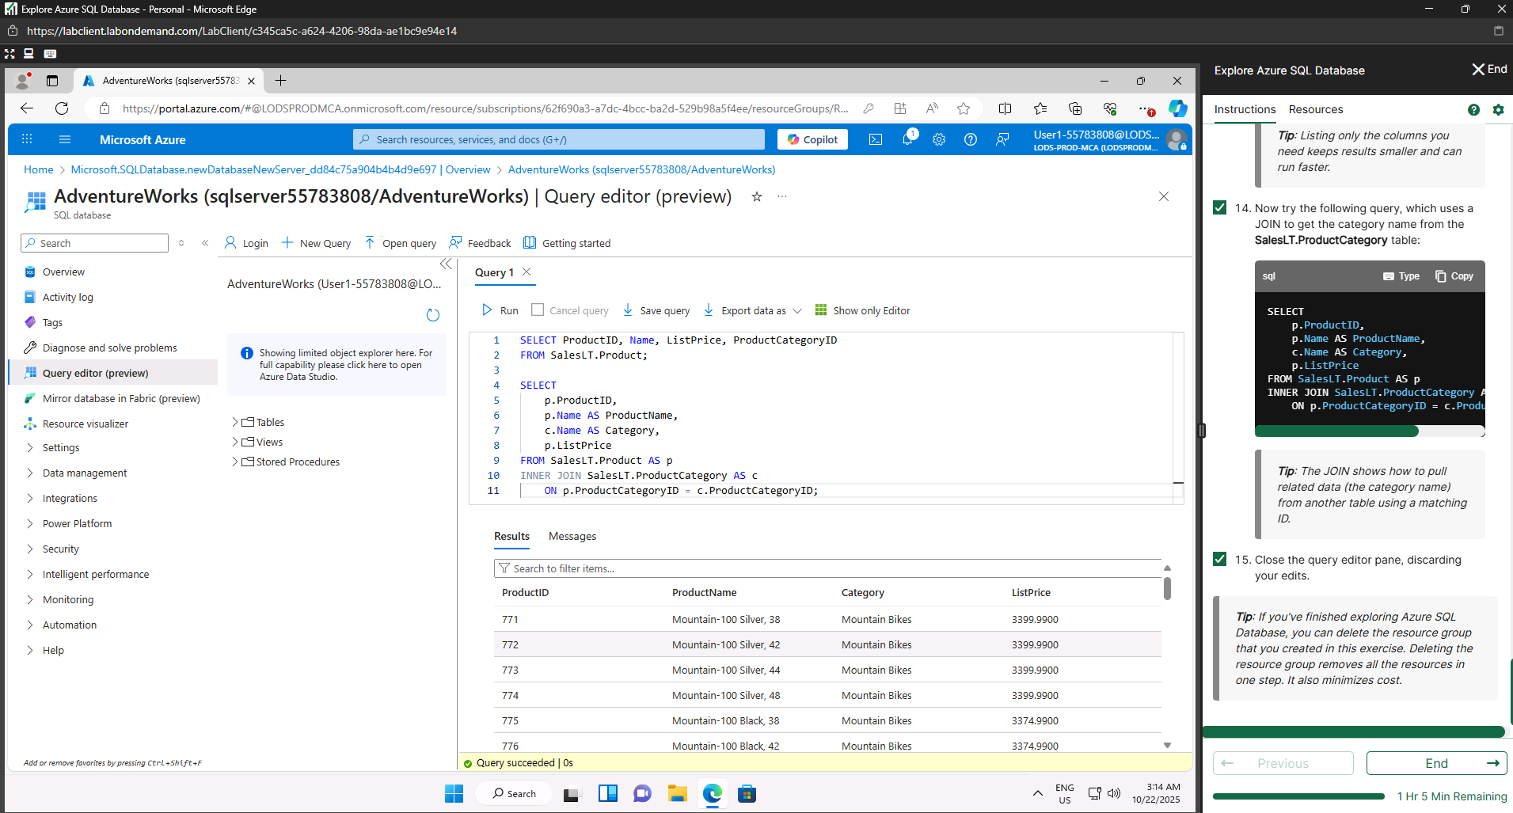

Day 3: Task 2

Please complete the below lab (4) ‘Explore non-relational data in Azure’ and paste evidence of the completed lab in the box provided.



Completed lab | 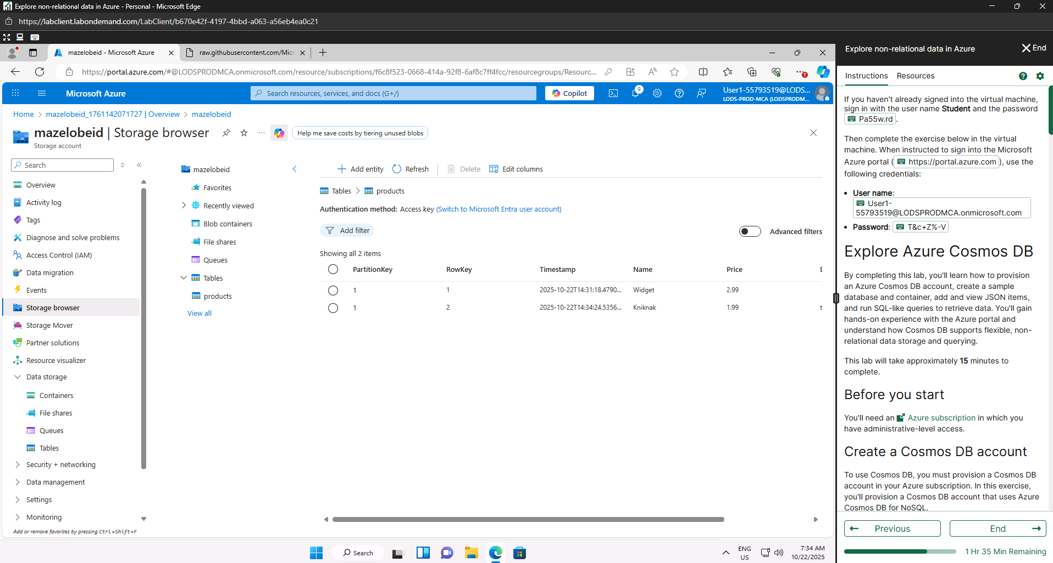  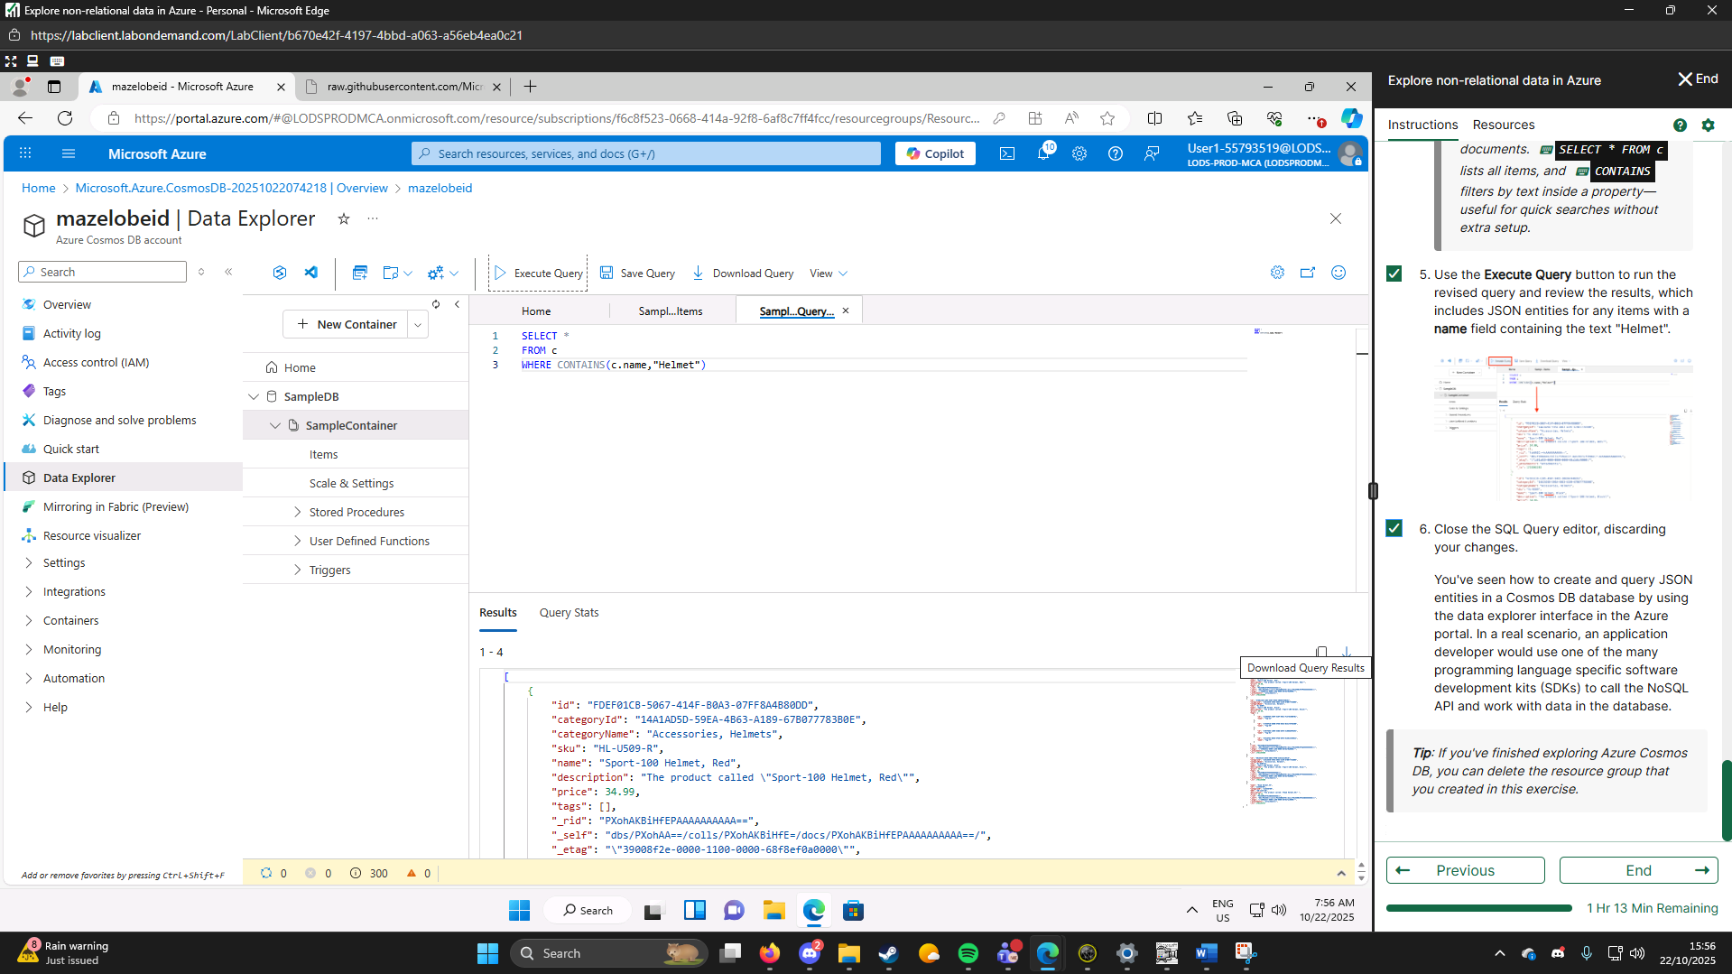

Day 3: Task 3

Please complete the below lab (5) ‘Explore data analytics in Azure’ and paste evidence of the completed lab in the box provided.

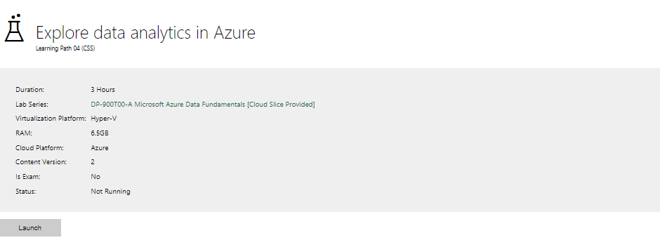

Completed lab | 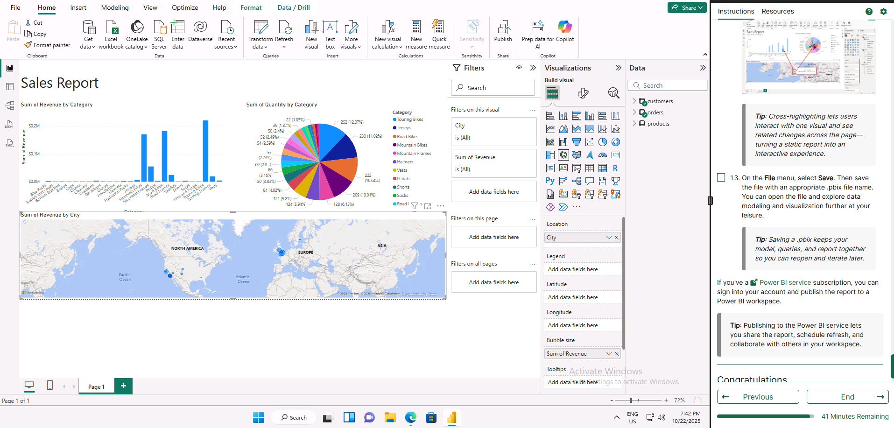

Day 4: Task 1

In your teams, complete the Azure DP-900 practice exam and paste your result below – this is open book and please research and discuss your answers as a team.


Result | 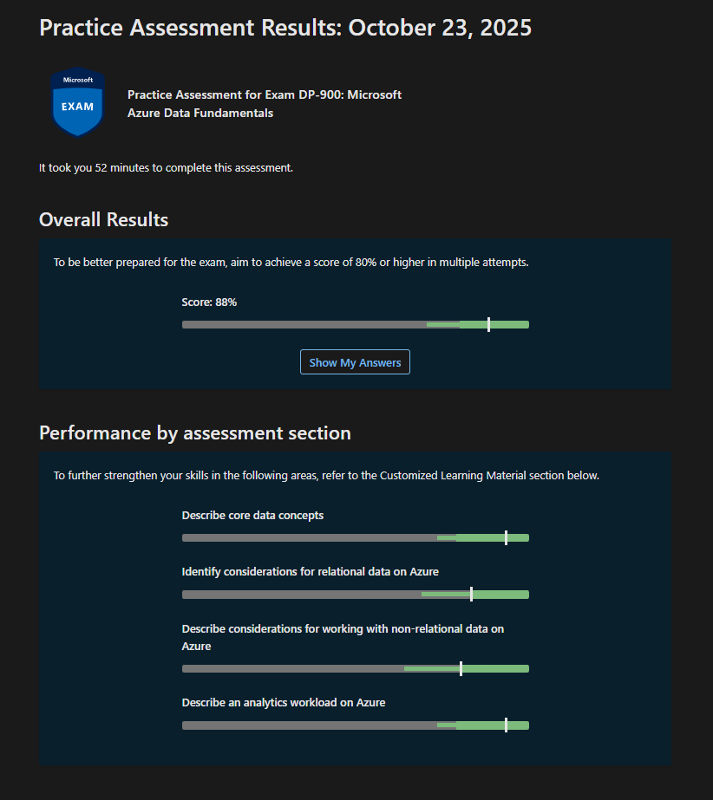

Day 4: Task 2

1. Scenario Background
"Paws & Whiskers" is a growing pet shop that aims to improve its business by analysing sales, customer information, and inventory data. Currently, the data is collected manually or stored in spreadsheets. Management is interested in transitioning to Microsoft Azure to streamline data storage, analysis, and reporting, enabling them to make data-driven decisions.

2. Data Laws and Regulations
Identify and explain the data laws and regulations relevant to handling customer data within the proposal. Ensure you cover the following points:
- GDPR Compliance: Highlight the importance of adhering to the General Data Protection Regulation (GDPR), particularly as it relates to storing and processing customer information.
- Data Protection Act (DPA) 2018: Outline how the DPA 2018 may affect the way "Paws & Whiskers" collects and stores data, ensuring compliance with UK laws on data privacy.
- Other Industry Standards: Research any additional data protection standards or regulations that may apply to pet shop data, particularly if they involve sensitive or payment information.

3. Azure Service Recommendations
Recommend Microsoft Azure services that would suit the company’s data analysis needs and explain why these services are suitable. Your recommendations should include:
- Data Storage: Identify suitable storage options, such as Azure Blob Storage or Azure SQL Database, and discuss the benefits of each for storing large datasets, including inventory, sales transactions, and customer details.
- Data Analysis Tools: Recommend tools such as Azure Machine Learning for customer behaviour analysis or Azure Synapse Analytics for analysing sales trends.
- Data Integration and Automation: Explain how services like Azure Data Factory could automate data collection and integration processes, improving efficiency.

4. Data Types and Data Modelling
Define the types of data "Paws & Whiskers" will need to work with and describe your approach to data modelling:
- Data Categories: Identify key data types, such as customer demographics, transaction history, pet inventory, and product categories.
- Data Modelling Approach: Outline how you would structure this data using a relational model or a data warehouse approach, considering factors like tables, entities, relationships, and primary keys.

5. Data Storage Formats and Structures in Azure
Discuss how you would store data within Azure and the formats you would recommend:
- Data Formats: Specify recommended formats (e.g., CSV for raw data imports, JSON for structured data, Parquet for analytics) and explain why these formats are suitable for specific data types.
- Data Security and Encryption: Include recommendations for securing data using Azure’s built-in encryption features and access controls to ensure compliance with data privacy regulations.

6. Additional Considerations
Provide any other considerations that might enhance data handling and efficiency in Azure, such as:
- Backup and Disaster Recovery: Outline a backup plan using Azure Backup or Azure Site Recovery to safeguard against data loss.
- Data Visualisation: Discuss potential use of Power BI within Azure for creating dashboards that provide management with real-time insights into sales and customer trends.
- Future Scalability: Comment on how Azure services can scale as the business grows, accommodating larger datasets and more complex analyses.

Submission Guidelines:
- Structure: Ensure your report is well-organised, with sections for each task (e.g., Data Laws, Azure Services, Data Types, etc.).
- Formatting: Include headings, bullet points where appropriate, and any visuals or diagrams that support your explanations.
- References: Cite any resources or regulations referenced in the report.
- Length: Aim for 1500-2000 words.

By switching from manual and spreadsheet-based record keeping to a cloud-based data management system, "Paws & Whiskers," a medium sized pet store, hopes to revolutionise its company operations. At the moment, sales transactions, inventory logs, and customer information are kept in various forms, which frequently results in data redundancy, discrepancies, and analysis challenges.
"Paws & Whiskers" may centralise its data architecture, optimise data flows, and acquire strong analytical capabilities by moving to Microsoft Azure. The integrated ecosystem of Azure makes possible:
- scalable and safe data storage that lessens dependency on local hardware.
- automated integration of data from several company systems, including online sales, supplier databases, and point of sale systems.
- AI-powered insights and advanced analytics for targeted marketing, inventory efficiency, and customer behaviour prediction.
- Power BI dashboards provide real-time information, enhancing operational insight and decision-making.
In the end, the organisation will be able to make data-driven decisions, enhance customer satisfaction, and increase overall operational efficiency thanks to this digital transformation.

Data Laws and Regulations
- Organisations handling the personal data of EU or UK citizens are subject to stringent regulations stipulated by the GDPR (EU Regulation 2016/679). GDPR compliance is crucial because "Paws & Whiskers" gathers personally identifiable consumer data, including names, addresses, payment information, and pet ownership information.

Important Guidelines for GDPR Compliance:

- Lawfulness, Fairness, and Transparency: Clients need to know exactly what information is being gathered, why, and how it will be utilised.
- Limitation of Purpose: Information should only be utilised for justifiable commercial objectives, such processing sales or running targeted advertisements.
- Data minimisation: Only pertinent and essential information should be gathered.
- Accuracy and Retention: Information must be current, accurate, and kept for as long as necessary to meet legal or business requirements.
- Security and Integrity: To ensure data integrity, Azure services comply with GDPR by using audit logs, access control, and encryption.
- Customers have the right to request data access, rectification, deletion (also known as the "right to be forgotten"), and processing restriction.
Azure has built-in GDPR-compliant data handling features, such as audit logs, compliance certifications, and data residency guarantees.
- Data protection act (2018)
GDPR is enhanced by the UK Data Protection Act 2018, which adapts it to circumstances unique to the UK. This law requires "Paws & Whiskers" to:
- Assure that personal data is processed legally, in accordance with permission or a legitimate interest.
- To stop data breaches, put organisational and technical safeguards in place (tight access controls, encryption, and pseudonymization).
- For sensitive or extensive data processing, keep track of data processing documentation and perform Data Protection Impact Assessments (DPIAs).
- In the event of a breach involving personal data, notify the Information Commissioner's Office (ICO) within 72 hours.
- The Microsoft Trust Centre and Azure's Compliance Manager capabilities support compliance monitoring and produce audit-ready reports that meet DPA regulations.

- Other industry standards

PCI DSS (Payment Card Industry Data Security Standard) compliance is crucial since "Paws & Whiskers" manages financial and payment activities. Azure's PCI DSS Level 1 certification guarantees the security of all payment data processed using Azure SQL or related payment APIs.
Other pertinent standards consist of:
- The Information Security Management System standard is ISO/IEC 27001.
- Protecting personally identifiable information (PII) in cloud computing is covered by ISO/IEC 27018.
- Cyber Essentials (UK): A suggested framework to improve cybersecurity posture for small enterprises.

Azure Service Recommendations
A hybrid data architecture utilising essential Azure services is suggested in order to satisfy Paws & Whiskers' operational and analytical requirements.
- Data Storage

- SQL Database on Azure
- A relational database that is completely maintained and perfect for structured datasets like inventory tables, customer profiles, and sales transactions.
- supports real-time querying, stored procedures, and referential integrity.
- includes integrated threat detection, point-in-time restoration, and auto-scaling.

- Blob Storage on Azure
- ideal for unstructured data, like marketing materials, scanned invoices, and product photos.
- provides inexpensive, high-availability storage and easily connects with Synapse Analytics and Azure Data Factory.
- automatically assigns less expensive storage tiers to rarely accessed data by supporting lifecycle management.

- Gen2 Azure Data Lake Storage
- It is advised for extensive analytical data since it offers a centralised location for raw, processed, and curated datasets.
- optimised with Azure Synapse and Spark for parallel processing and big data analytics.

- Data Analysis Tools

- Synapse Analytics on Azure

- A potent analytics solution that blends big data with data warehousing.
- Allows for the use of both SQL and Spark engines for querying pet product trends, sales seasonality research, and cross-store comparisons.

- Azure Machine Learning

- Used in predictive analytics to find potential high-value clients or estimate demand for particular pet food products.
- Provides an integrated workspace that makes model training, deployment, and monitoring easier.

- Databricks for Azure
- Allows analysts and data engineers to work together to create machine learning models and sophisticated analytics pipelines.
- Easily connects to Synapse and Data Lake.

- Data Integration and Automation
The primary ETL (Extract, Transform, Load) and orchestration tool will be Azure Data Factory (ADF) can:
- Take in information from third-party APIs (such as supplier feeds), POS systems, and spreadsheets that are located on-site.
- Data should be cleaned and converted to specified formats.
- Set up automated procedures to refresh data every day or every hour.
ADF can be used in conjunction with Logic Apps or Power Automate to automate workflows, such as sending out alerts when stock levels fall below predetermined levels.

Data Types and Data Modelling
- Types of Data

- Customer information includes contact choices, pet profiles, loyalty memberships, and personal information.
- Sales information includes POS transactions, payment histories, usage of discounts, and in-store or online sales channels.
- Product SKUs, supplier information, available stock, and reorder levels are examples of inventory data.
- Operational data includes marketing campaign performance indicators, supplier invoicing, and employee rosters.

- Data Modelling approaches

Relational Data Model (Operational Layer): Applied to daily business transactions in Azure SQL Database. Examples of entities.

- Customer (Name, Email, Phone, LoyaltyPoints, and CustomerID)
- The product's supplier ID, price, category, product ID, and stock level
- Transaction (ID, Quantity, Date, Payment Type, CustomerID, ProductID)
- Supplier (Contact Information, Company Name, Supplier ID)

Using a star schema, the Data Warehouse Model (Analytical Layer) was deployed on Azure Synapse.
- Fact Table: Sales Transactions (connected to product dimensions, time, and customer).
- Customer, Product, Time, and Store Location Dimension Tables.
- Both long-term trend analysis and real-time operational queries are effectively supported by this dual-layer technique.

Data Formats and Structures in Azure
- Data Formats
Data Type | Recommended Format | Function/Reason
 |  | Easy ingestion from legacy spreadsheets and external systems.
  Raw Imports
  CSV
 |  | Ideal for structured, nested data (e.g., customer pet profiles).
  Web/API Data
  JSON
 |  | Compressed, columnar format optimised for query performance in Synapse.
  Analytical Data
  Parquet
 |  | Supports schema evolution and efficient log analytics.
  Logs / Events
  Avro

- Data security and Encryption

Azure offers all-encompassing security by:

- Encryption at Rest: All stored data should be encrypted using AES-256-bit.
- Encryption in Transit: HTTPS/TLS 1.2 secure connections.
- Centralised administration of encryption keys, secrets, and certificates is possible with Azure Key Vault.
- Only permitted users or roles are allowed access thanks to role-based access control, or RBAC.
- Azure Defender for SQL and Storage: Offers anomaly detection and sophisticated threat defence.

These elements guarantee adherence to the security rules of the GDPR and shield payment and customer data from breaches or unauthorised access.

Additional Considerations

- Backup and Recovery

- Azure Backup: Enables point-in-time restoration by automating database and file backups.
- Azure Site Recovery: Provides business continuity in the event of outages or disasters by replicating workloads across regions.
- For increased resilience, Geo-Redundant Storage (GRS) makes sure that data is replicated across several locations.
- Data Visualisation

- Dashboard for Sales Performance: Revenue by time period, region, and category.
- Customer Insights Dashboard: Loyalty trends, churn statistics, and top-spending customers.
- Inventory Dashboard: Supplier performance, reorder alerts, and real-time stock levels.

- Scalability for the future

Azure's elastic scalability guarantees that the infrastructure may expand in tandem with the company:
- dynamic resource scaling for computation and storage.
- Pay-as-you-go to keep expenses under control.
- Future features include integration with AI and IoT services (such intelligent inventory tracking).
By moving to Microsoft Azure, "Paws & Whiskers" will be able to create a scalable, secure, and compliant data ecosystem. The business may increase operational effectiveness, guarantee long-term compliance with data security regulations, and gain actionable insights with centralised storage, automated data integration, and advanced analytics.

References/Citations
About TMC. (n.d.). Microsoft Azure and GDPR: How can MS Azure ease your journey to GDPR compliance? About TMC. Retrieved October 23, 2025, from https://abouttmc.com/blog/microsoft-azure-and-gdpr-how-can-ms-azure-ease-your-journey-to-gdpr-compliance/
Apply to Supply Digital Marketplace. (n.d.). Azure Site Recovery. Digital Marketplace (UK Government). Retrieved October 23, 2025, from https://www.applytosupply.digitalmarketplace.service.gov.uk/g-cloud/services/433249406459060
Azure Critical Cloud. (n.d.). Azure Backup compliance with PCI DSS standards. Azure Critical Cloud. Retrieved October 23, 2025, from https://azure.criticalcloud.ai/azure-backup-compliance-pci-dss-standards/
Learn Microsoft. (n.d.). Azure Backup security controls and policy. Microsoft Learn. Retrieved October 23, 2025, from https://learn.microsoft.com/en-us/azure/backup/security-controls-policy
Learn Microsoft. (n.d.). Data Protection Impact Assessments (DPIA) in Azure. Microsoft Learn. Retrieved October 23, 2025, from https://learn.microsoft.com/en-us/compliance/regulatory/gdpr-dpia-azure
Learn Microsoft. (n.d.). Data subject requests for Azure (GDPR). Microsoft Learn. Retrieved October 23, 2025, from https://learn.microsoft.com/en-us/compliance/regulatory/gdpr-dsr-azure
Learn Microsoft. (n.d.). GDPR overview for Microsoft products and services. Microsoft Learn. Retrieved October 23, 2025, from https://learn.microsoft.com/en-us/compliance/regulatory/gdpr
Learn Microsoft. (n.d.). Integrate Azure Machine Learning with Azure Data Factory. Microsoft Learn. Retrieved October 23, 2025, from https://learn.microsoft.com/en-us/azure/machine-learning/how-to-data-ingest-adf
Learn Microsoft. (n.d.). Link Azure Synapse Analytics and Machine Learning workspaces. Microsoft Learn. Retrieved October 23, 2025, from https://learn.microsoft.com/en-us/azure/machine-learning/how-to-link-synapse-ml-workspaces
Learn Microsoft. (n.d.). Machine learning integration in Azure Synapse Analytics. Microsoft Learn. Retrieved October 23, 2025, from https://learn.microsoft.com/en-us/azure/synapse-analytics/machine-learning/what-is-machine-learning
Learn Microsoft. (n.d.). Payment Card Industry Data Security Standard (PCI DSS) offering in Azure. Microsoft Learn. Retrieved October 23, 2025, from https://learn.microsoft.com/en-us/azure/compliance/offerings/offering-pci-dss
Microsoft Azure. (n.d.). Global infrastructure and data residency. Azure. Retrieved October 23, 2025, from https://azure.microsoft.com/en-gb/explore/global-infrastructure/data-residency
Microsoft Azure. (2018, April 30). New capabilities to enable robust GDPR compliance. Azure Blog. Retrieved October 23, 2025, from https://azure.microsoft.com/en-us/blog/new-capabilities-to-enable-robust-gdpr-compliance/

Microsoft Trust Center. (n.d.). GDPR overview and Microsoft compliance commitments. Microsoft. Retrieved October 23, 2025, from https://www.microsoft.com/en-us/trust-center/privacy/gdpr-overview

Stridely Solutions. (n.d.). Understanding Azure Data Factory (ADF) and its integration capabilities. Stridely Solutions. Retrieved October 23, 2025, from https://www.stridelysolutions.com/insights/blog/azure-data-factory-adf/
Varonis. (n.d.). Azure compliance: A complete guide to security and regulations. Varonis Blog. Retrieved October 23, 2025, from https://www.varonis.com/blog/azure-compliance

Course Notes

It is recommended to take notes from the course, use the space below to do so, or use the revision guide shared with the class:

Additional Information

We have included a range of additional links to further resources and information that you may find useful, these can be found within your revision guide.

END OF WORKBOOK

Please check through your work thoroughly before submitting and update the table of contents if required.

Please send your completed work booklet to your trainer.

